MULTIPLICATION PROBLEMS

KS1 – 2001 Paper

1.

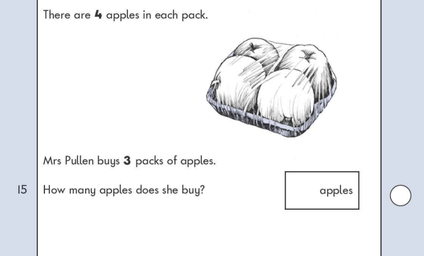

KS1 – 2002 Papers

2.

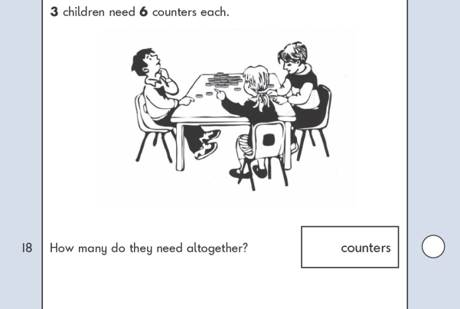

3.

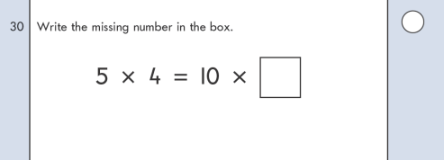

KS1 - 2003 Paper

4.

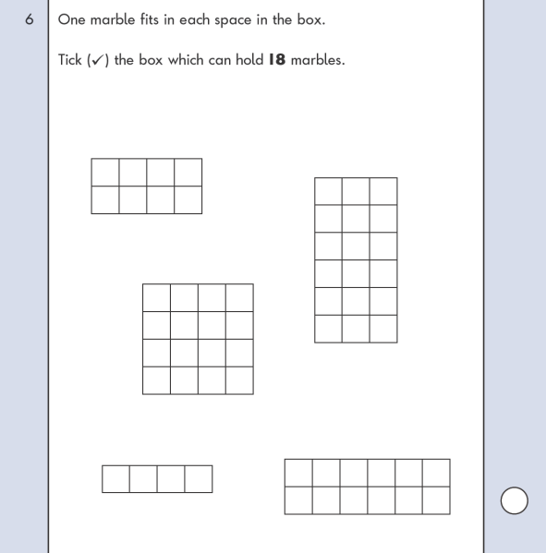

KS1 – 2004 Paper 1

5.

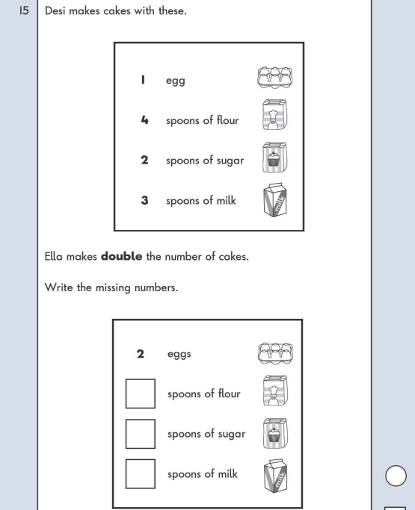

6.

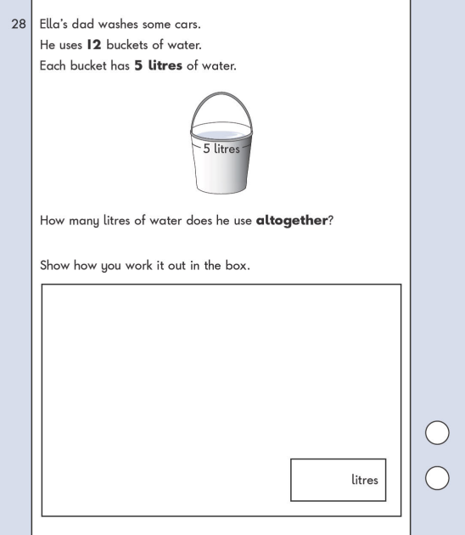

KS1 – 2004 Paper 2

7.

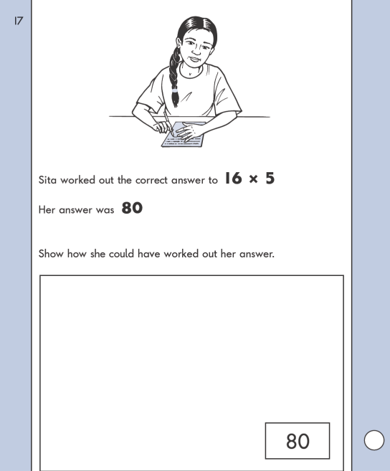

KS1 – 2005 Paper 1

8.

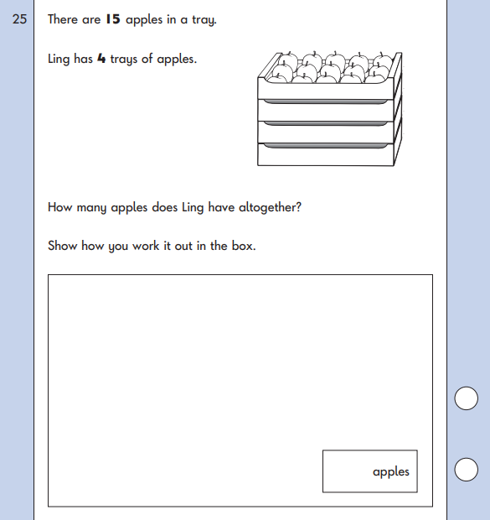

KS1 – 2005 Paper 2

9.

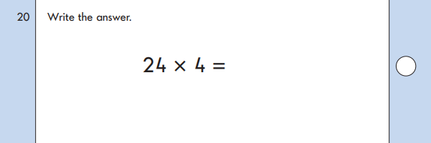

KS1 – 2007 Paper 2

10.

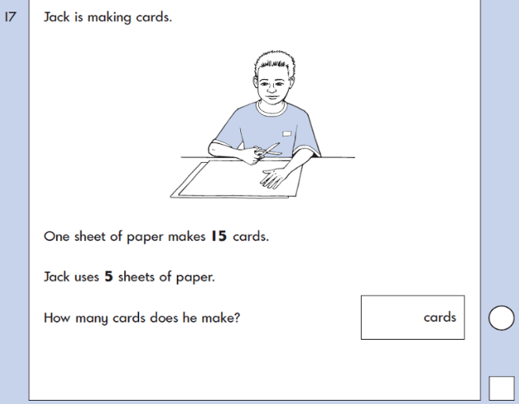

11.

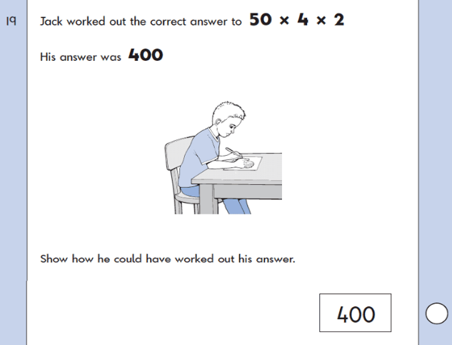

KS1 – 2009 Paper 1

12.

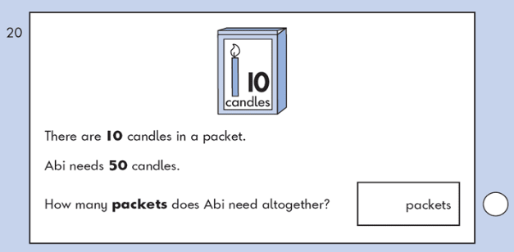

KS1 – 2009 Paper 2

13.

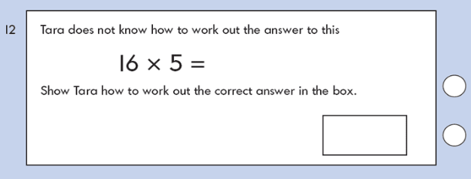

KS1 – 2016 Paper – Reasoning (Second)

14.

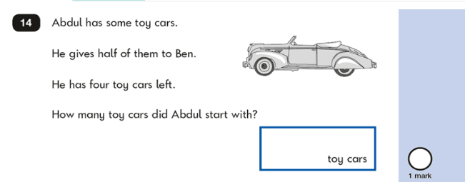

KS1 – 2017 Paper – Arithmetic

15.

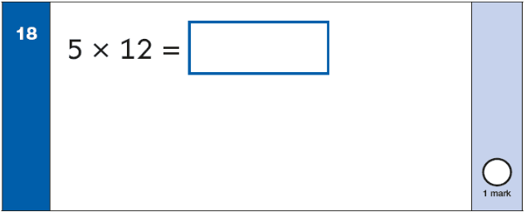

KS1 – 2017 Paper – Reasoning

16.

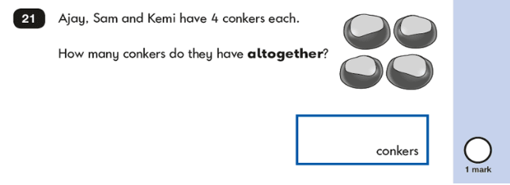

17.

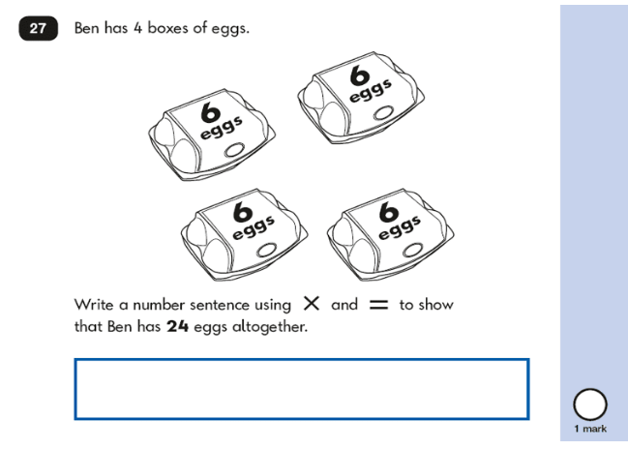

KS1 – 2018 Paper – Arithmetic

18.

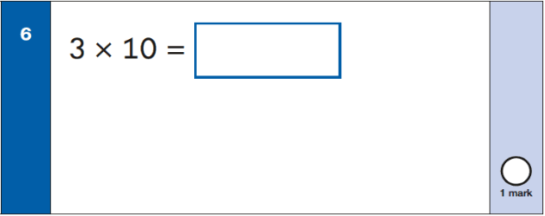

KS1 – 2018 Paper – Reasoning

19.

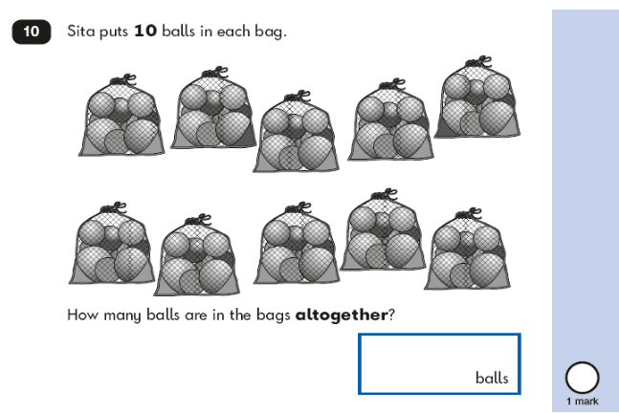

20.

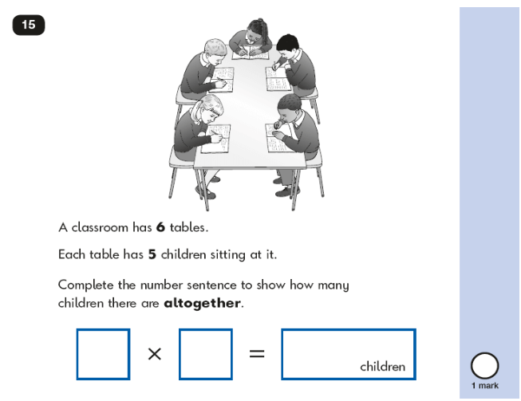

KS1 – 2019 Paper – Reasoning

21.

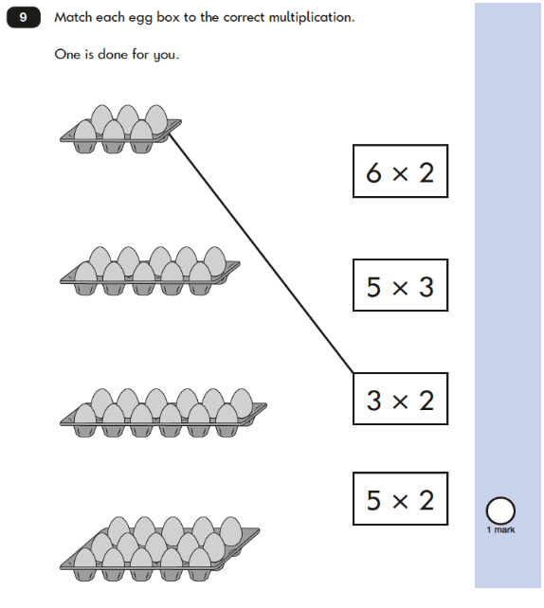

22.

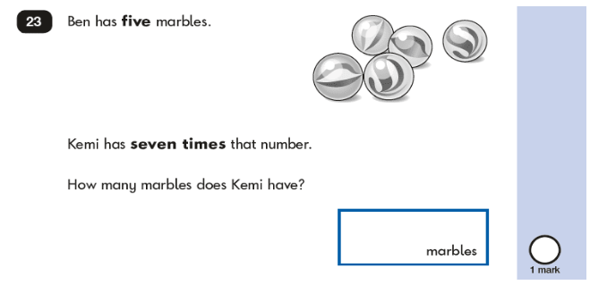

KS1 – 2022 Paper – Reasoning

23.

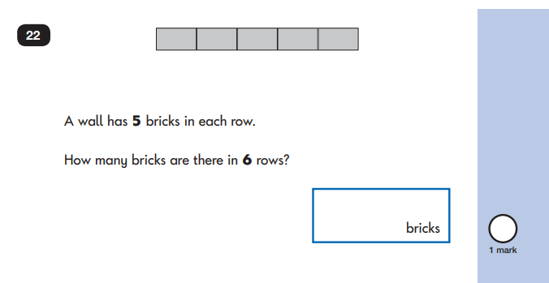

24.

